ADP PROJECT,BUSINESS REGISTRATION FORM
USING FRAMES

BY HARIRAJ .M
B.TECH. IT. A.

ADP PROJECT
BUSINESS REGISTRATION FORM

CONTENT

- HTML CODE FOR BUSINESS REGISTRATION FORM
- OUTPUT
- HTML CODE FOR BUSINESS LOGO
- OUTPUT
- HTML CODEE OF JOINING THEM USING FRAMES
- OUTPUT

- HTML C ODE FOR BUSINESS REGISTRATION FORM

<!DOCTYPE html>
<html>
<body style=”background-color:bisque;”>
<h2>VEDAAN PRODUCTS</h2>

table{
background-image:url('business.jpg');
background-size:cover;
border-collapse:collapse;
width:100%;
}
th,td{color:blue;}
</style>
</head>
<fieldset>
<body>
<table>
<form method=""post"action="quiz3.php">
<legend><h3style="color:blue;>BUSINESS REGISTRATION FORM<h3><legend>
<tr>
<th style="padding:0px 0px10px 20px;"><h2>if you want to be a sub part of <mark style="background-color:powderblue;">VEDAAN PRODUCTS</mark>register the following form</h2></th>
</tr>
<tr>
<td style="padding:0px 0px 10px 20px;"><b>Business Owner*<b><td>
</tr>
<tr><td style="padding:0px 0px 10px 20px;"><input type="text" size=45
placeholder="firstname">&nbsp<input type="text" size=45 placeholder="lastname"></td></tr>
<td style="padding-left:20px;"><b>Business Name*<b></td>
</tr>
<tr><td colpsan="2" style="padding:0px 0px 10px 20px;"><input size=100type="text"
placeholder="business name"></td></tr>
<td style="padding-left:20px;"><b>Contact Number*</b></td>
</tr>
<tr><td colpsan="2" style="padding:0px 0px 10px 20px;"><input size=100 type="text"
placeholder="##########"></td></tr>
<tr>
<td style="padding-left:20px;"><b>E-mail*</b></td>
</tr>
<tr><td colpsan="2" style="padding;0px 0px 10px 20px;"><input size=100 type"text"
placeholder="email"></td></tr>
<tr>
<td style="padding:0px 0px 10px 20px;"><b>Address*<b><td>
</tr>
<tr><td colpsan="2" style="padding;0px 0px 10px 20px;"><input size=100 type"text"
placeholder="Street Address"></td></tr>
<tr><td colpsan="2" style="padding;0px 0px 10px 20px;"><input size=100 type"text"
placeholder="Street Address Line-2"></td></tr>
<tr><td style="padding:0px 0px 10px 20px;"><input type="text" size=45
placeholder="City">&nbsp<input type="text" size=45 placeholder="Region"></td></tr>
<tr><td style="padding:0px 0px 10px 20px;"><input type="text" size=45
placeholder="Zip code">&nbsp<input type="text" size=45 placeholder="Country"></td></tr>
<td style="padding:0px 0px 5px :20px;"><b>Type of Business*</b></td>
<tr><td colpsan="2" style="padding;0px 0px 10px 20px;"><input size=100 type"text"
placeholder="please select"></td></tr>
<td style="padding:0px 0px 5px 20px;"><b>Message*</b></td>
<tr><td colpsan="2"style="padding;0px 0px 10px 20px;"><textarea rows=3 cols=94
placeholder="message"></textarea></td></tr>
<tr><td style="padding:0px 0px 63px 20px;"><button class="button_css">
Register Business</button></td></tr>
<form>
</table>
</body>
<html>
TAG USAGES

- TABLE

- FORM

- FIELDSET

- MARK

- BOLD

- LEGEND

- HEADING TAGS

- CSS STYLE

- OUTPUT 1

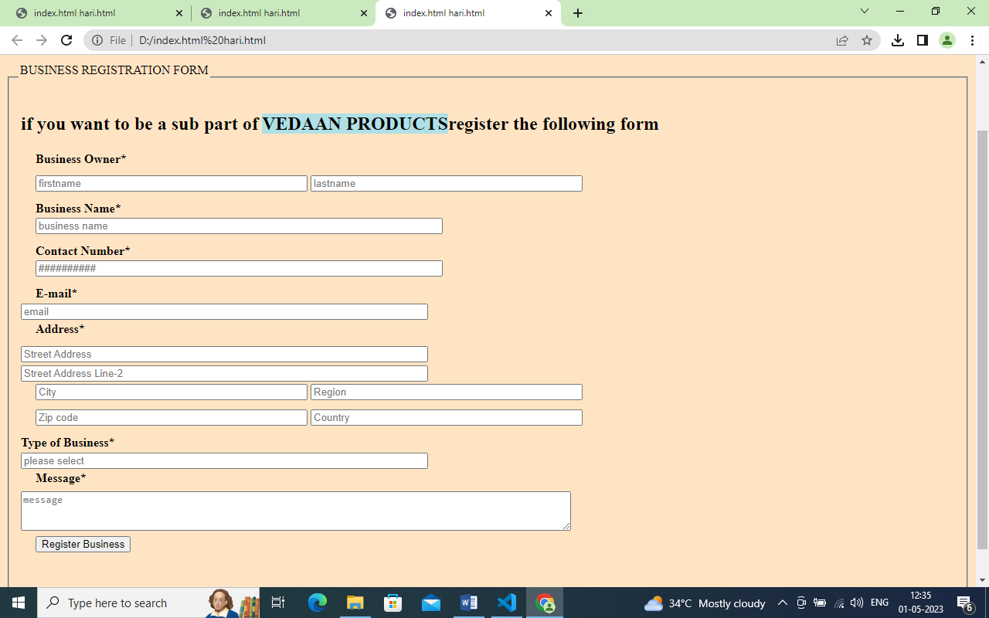

3.HTML CODE FOR BUSINESS SYMPOL

<html>
<head><title>images</title></head></head>
<body>
<img src="D:\Hari_Raj\html\images.jpg" width="300" height="300" border="12px solid yellow">
<h3>VEDAAN PRODUCTS. 100% NATURAL</h3>
<h3>VEDAAN BATH POWDER.</h3>
<h4>VEDAAN TOOTH POWDER</h4>
<h4>VEDAAN HAIR PRODUCTOR</h4>
<h4>VEDAAN TRIBALA POWDER</h4>
<h4>VEDAAN TRIKADUGAM</h4>
<h4 style="padding-left:120px;">On of the greatest Organisation by <h4>
<h4 style="padding-left:120px;">HARIRAJ.M</h4>
</body>
</html>

TAG USAGES

- IMG

- TEXT ELEMENTS

- CSS STYLE FOR BACKGROUND

- OUTPUT 2

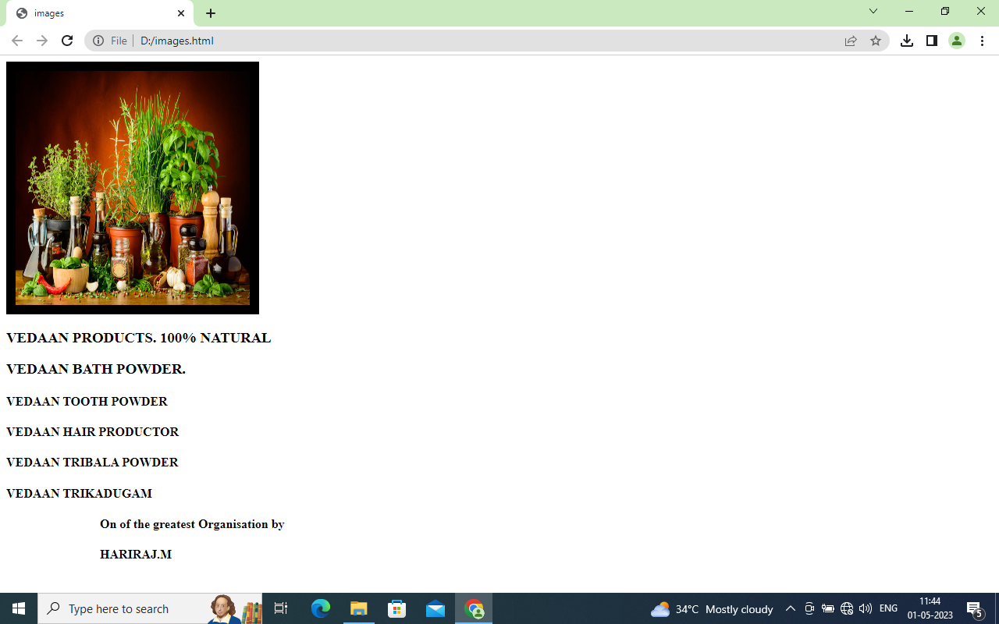

- HTML CODE TO BRING THE TWO HTML CODES USING FRAME
<html>
<head><title>college project</title></head>
<frameset cols="50%,50%">
<frame name="left" src="index.html hari.html"/>
<frame name="right" src="D:\images.html">
</frameset>
<html>

TAG USAGE

- FRAMESET

- FRAME

- SRC ATTRIBUTE

- OUTPUT 3.

